

Bachelor of Computer Applications
Semester – V
Business Analytics
Experiment No: 4
Title: Data Cleaning using Power Query

Submitted By
Name: Suraj Mal Gurjar
Reg. No.:2411021240009
Date:09-09-2026

Submitted To:
Faculty Name: Mr. Aman Kumar Sharma

Department of Computer Application
Alliance University
Chandapura - Anekal Main Road, Anekal
Bengaluru – 562106

Experiment No.: 4
Data Cleaning using Power Query

Problem Statement
A cafe company has received customer transaction data containing missing values, blank cells, null values, and inconsistent entries. The objective is to clean and prepare the dataset using Power Query so that it becomes accurate, consistent, and ready for business analysis.

Methodology / Steps Followed

Step 1: Data Collection
- Collected the Dirty Cafe Sales dataset in CSV format.
- The dataset contains transaction details, product information, payment method, location, quantity, price, and transaction date.
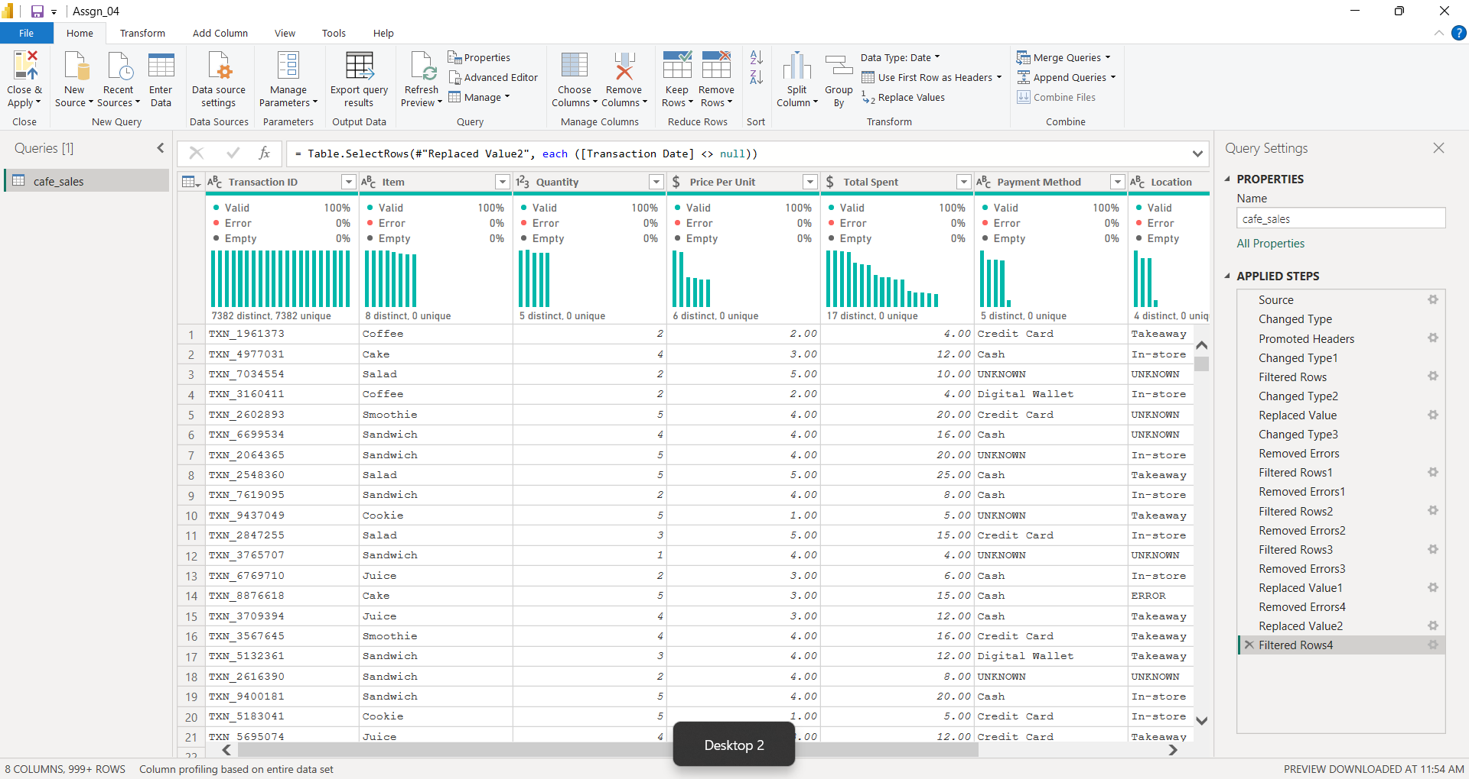

Step 2: Data Import
- Opened Microsoft Power BI Desktop.
- Selected Get Data → Text/CSV.
- Imported the dirty_cafe_sales.csv dataset.
- Clicked Transform Data to open Power Query Editor.
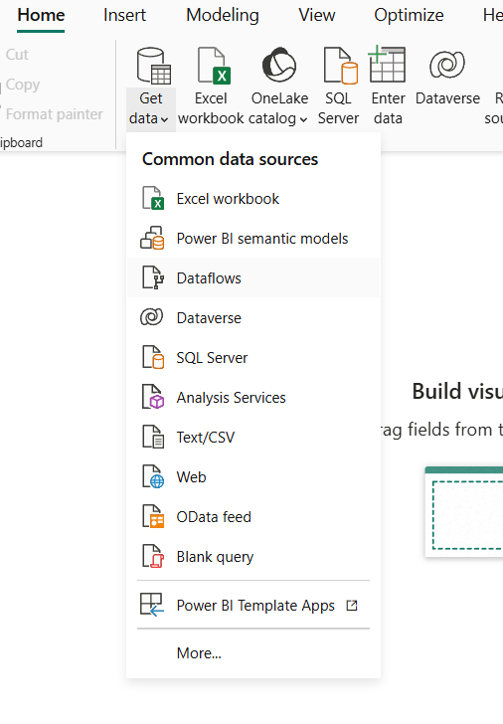

Step 3: Data Cleaning and Transformation
The dataset was cleaned using the following Power Query operations:
- Promoted the first row as column headers.
- Changed the data type of each column.
- Replaced invalid values (UNKNOWN and ERROR) with null.
- Filtered and removed empty, blank, and null records.
- Removed rows containing data errors.
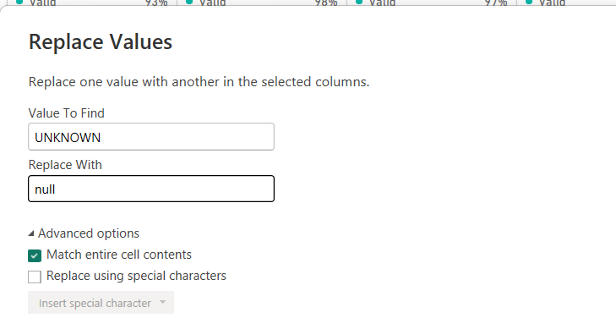
- Verified the cleaned dataset before loading it into Power BI.
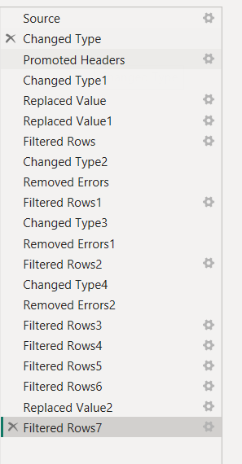

Step 4: Data Validation
After cleaning:
- Verified that all numeric columns were correctly formatted.
- Confirmed the transaction date was in Date format.
- Ensured no blank or invalid records remained.
- Loaded the cleaned dataset into Power BI for analysis.
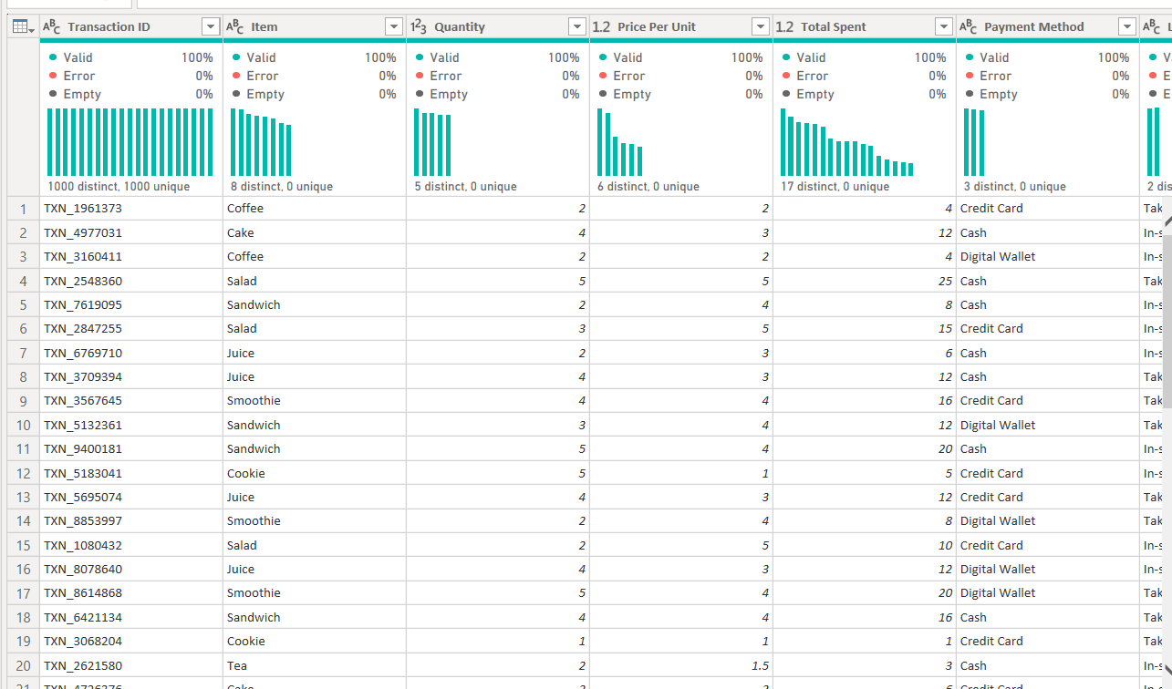

Output
The cleaned dataset provides:
- Accurate transaction records
- Standardized payment methods and locations
- Valid quantity and price values
- Correctly formatted dates
- Error-free data ready for visualization and analysis

Business Insights
After cleaning the dataset:
- Missing and null values were successfully removed.
- Invalid entries (UNKNOWN, ERROR) were corrected.
- Data types were standardized across all columns.
- The dataset became consistent and suitable for business reporting.
- Clean data improves the accuracy of dashboards and decision-making.

Conclusion
This experiment successfully cleaned and prepared the Dirty Cafe Sales dataset using Power Query. Missing values, blank cells, null records, and inconsistent entries were handled through data transformation techniques such as replacing values, filtering rows, removing errors, and correcting data types. The resulting dataset is reliable and ready for further analysis in Power BI.

Learning Outcomes
Through this experiment, I learned:
- Importing CSV datasets into Power BI
- Using Power Query for data cleaning
- Handling null, blank, and missing values
- Replacing inconsistent entries
- Removing errors and validating data quality
- Preparing datasets for accurate business analytics

GitHub Link : https://github.com/Suraj18-108/Business-Analytics-Projects/tree/main/Weekly%20Assignments/Assignment%204

